Experiment No. 1.3

Student Name: Parvinder Singh UID: 22MCC20043
Branch: MCA - CCD Section/Group: 22MCD-1/ Grp B
Semester: III
Subject Name: Containerization With Docker Subject Code: 22CAH-742

- Aim/Overview of the practical: Deploy Docker images as the stateless container.

- Code for experiment/practical:
To deploy Docker images as stateless containers, you can use a container orchestration platform such as Kubernetes or Docker Swarm. These platforms allow you to manage multiple containers across multiple hosts, and they provide features that make it easy to deploy stateless applications, such as:
- Automatic scaling: The platform can automatically scale the number of containers running your application up or down based on demand.
- Load balancing: The platform can distribute traffic across multiple containers running your application.
- Self-healing: If a container fails, the platform can automatically restart it on another host.

Steps to Deploy images as the stateless container:
- docker pull image_name
for Ex: docker pull nginx

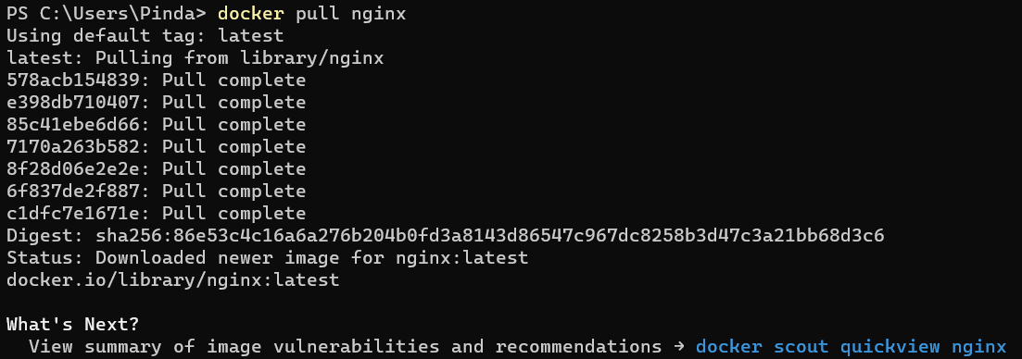

- docker run –name some-nginx -d -p 8080:80
- Go to browser localhost:8080

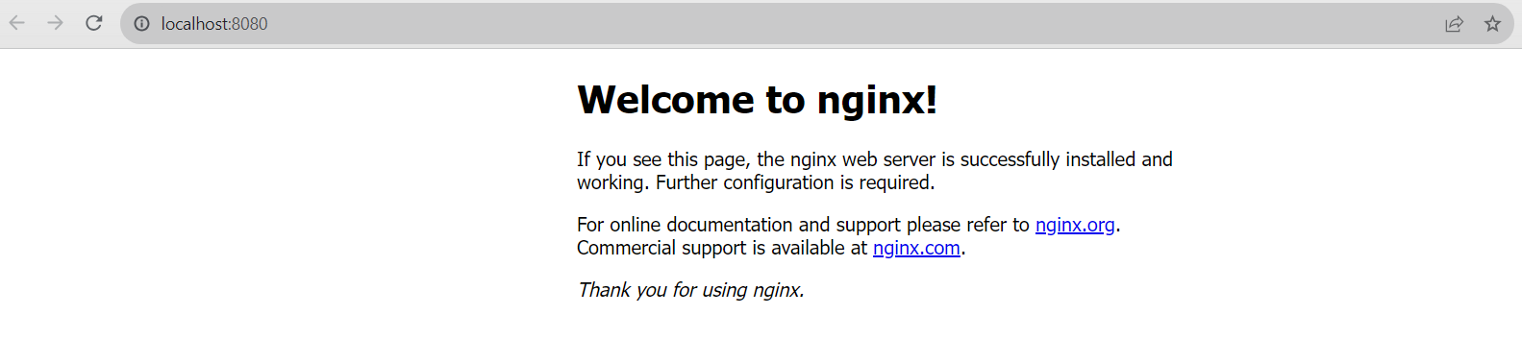

- Learning outcomes (What I have learned):
- To pull image from Dockerhub.
- To run Docker image on localhost port.
- Understand to use Docker Images commands.

